
Service now based employee laptop request Application


susmitha chinthakuntla
Btech final year

Project Documentation

1. Introduction

- Project Title : ServiceNow-Based Employee Laptop Request Application
- Technology : ServiceNow
- Project Category: ServiceNow Application Development
2. Road Map
Requirement Analysis
↓
Application Creation
↓
Table & Fields
↓
Form Configuration
↓
Roles & ACLs
↓
Flow Designer
↓
Manager Approval
↓
Approved / Rejected
Email Notifications
↓
Reports & Dashboard
↓
Testing
↓
Final Documentation
3.New Update set Creation
- Click on all menu >> type local update set under system update set select it.
- Click on the new button on top right.
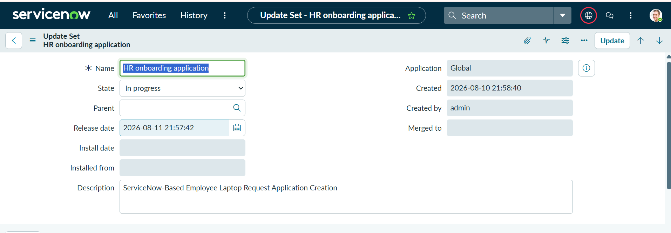
- Then give the name as HR onboarding application and state as In progress.

4.New Application Creation
- Go to all menus >> and select serviceNow studio.
- Create a new application with the name Employee Laptop Request select the scope is scoped and then click continue.
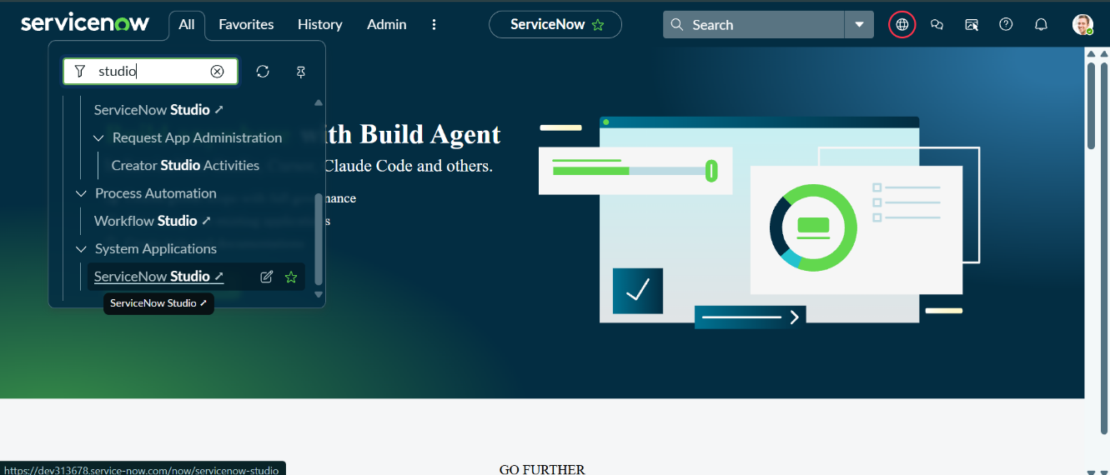
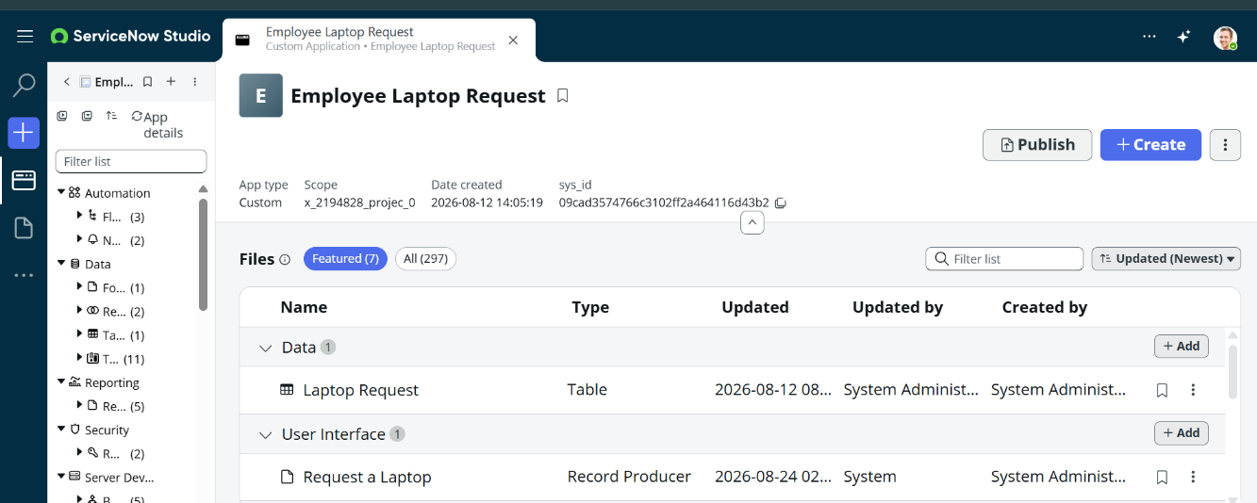
5.Table Creation
- ALL >> System Defination >> Tables
- Create a New Table named “Laptop Request”.
- Add Fields in the Table
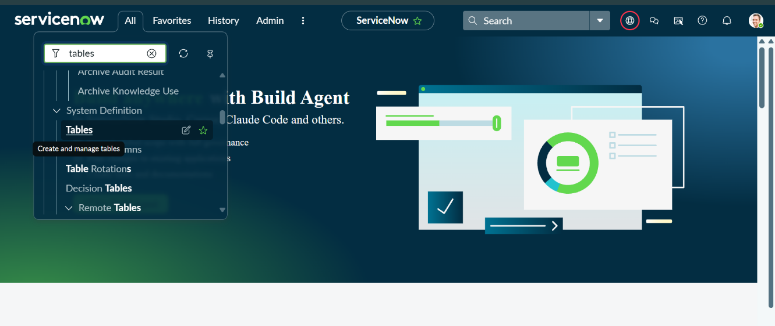
- AAAAA
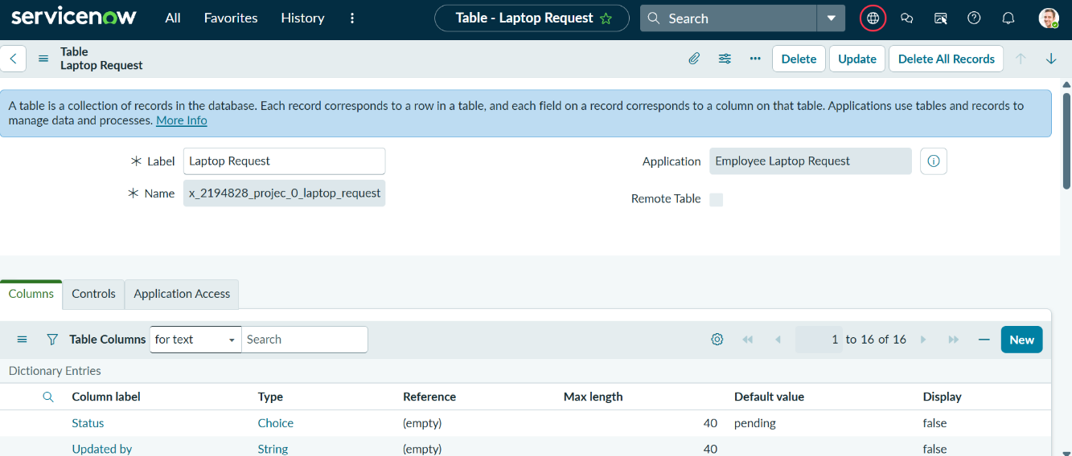

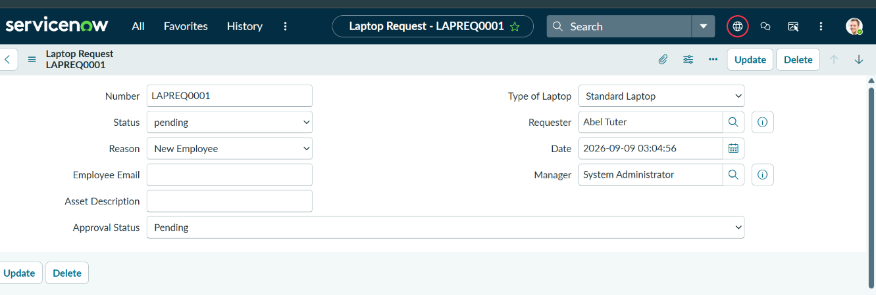

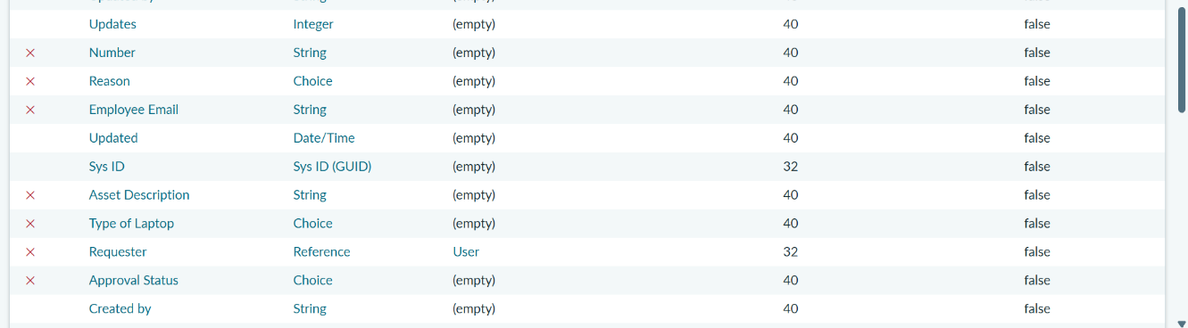

- New Record – Laptop Request

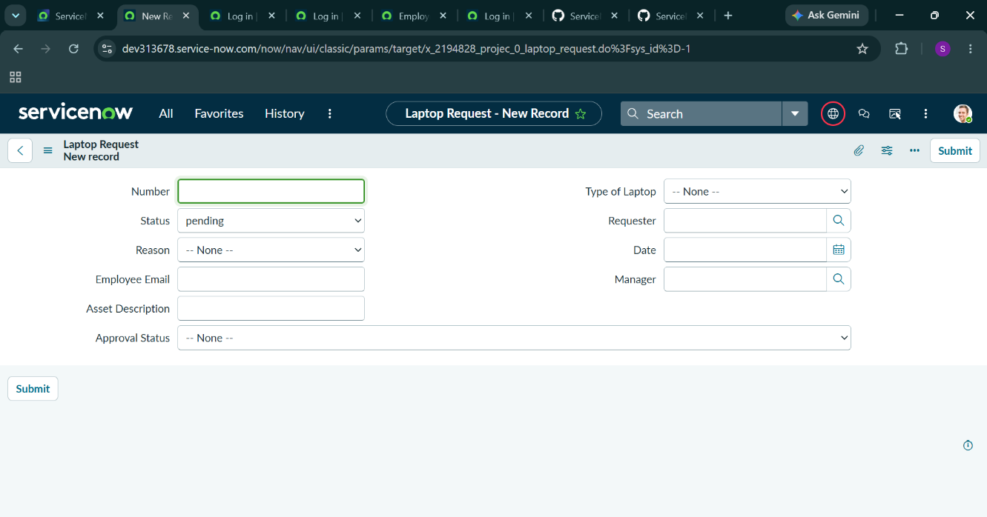
- Laptop Request Form Details

5.Purpose of Approval Relationship
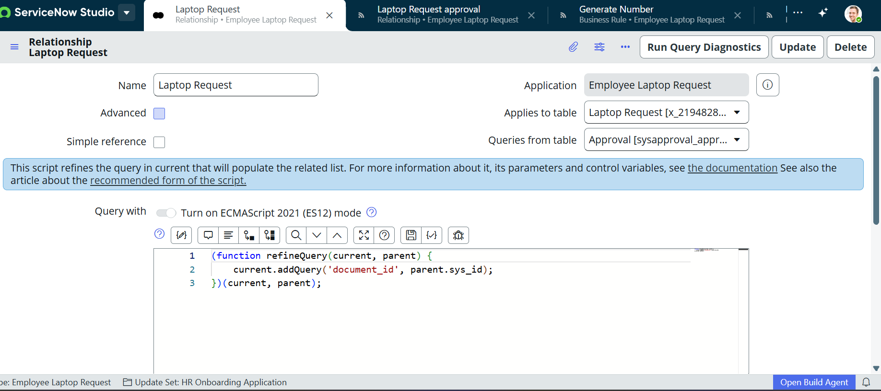

6.Record Producer Configuration
Navigate to Service Catalog → Catalog Definitions → Record Producers→ Click New
Created a new Record Producer:
- Name: Laptop Request.
- Table: Laptop Request Form.
- And the type of the field is the same as the table fields type.
- Save the form after adding fields as needed.
- Add variables to the record producer and that to map to fields of the table by giving the field name is question type.
- And also before that create a new catalog item name as employee service catalog and category as service.
- Added Record Producer to the Employee Service Catalog.
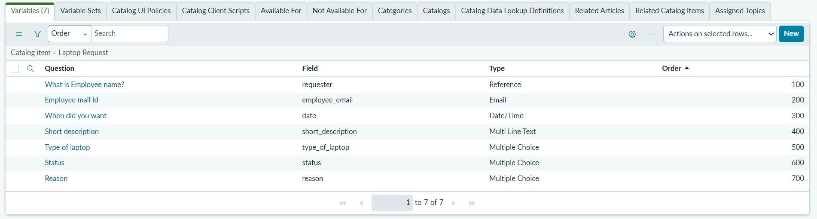

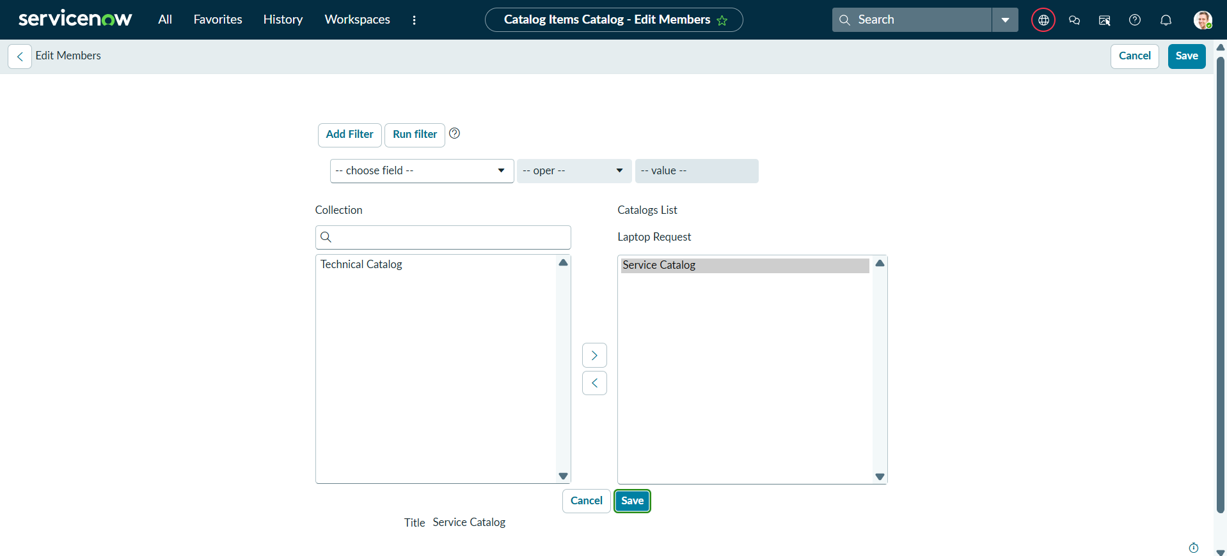

7.Flow Designer Setup

- ALL >> Flow Designer.
- Create a Flow and Make it Activate and Test after adding actions to that.
Explain how Flow Designer automates the request lifecycle.

Trigger:
- When: Record Created
- Table: Laptop Request Form
Flow Steps:
- Initialize request.
- Set status to Pending Approval.
- After the Submission of Laptop Request Details , send a Notification to Employee
- Ask for manager approval.
- Wait for approval or rejection.
- If approved, update status to Approved.
- If rejected, update status to Rejected.
- Complete Flow Designer flow
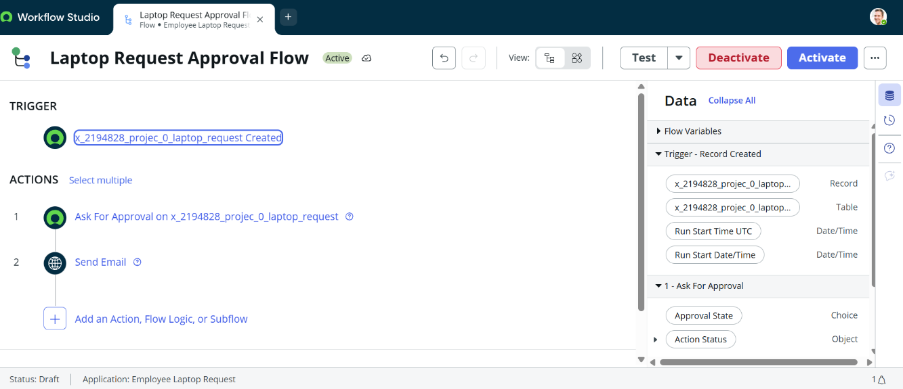
- Create a Laptop request

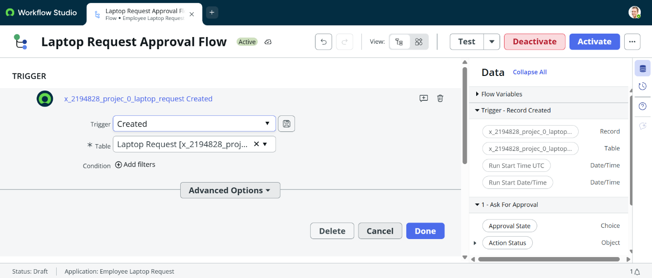
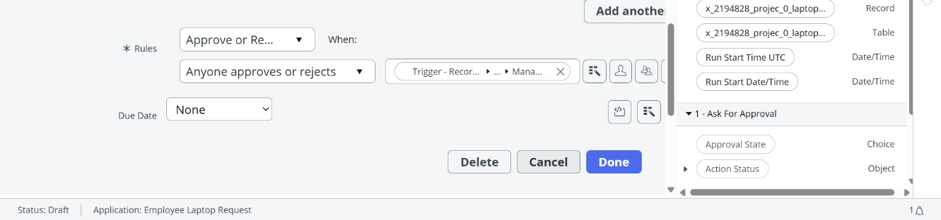
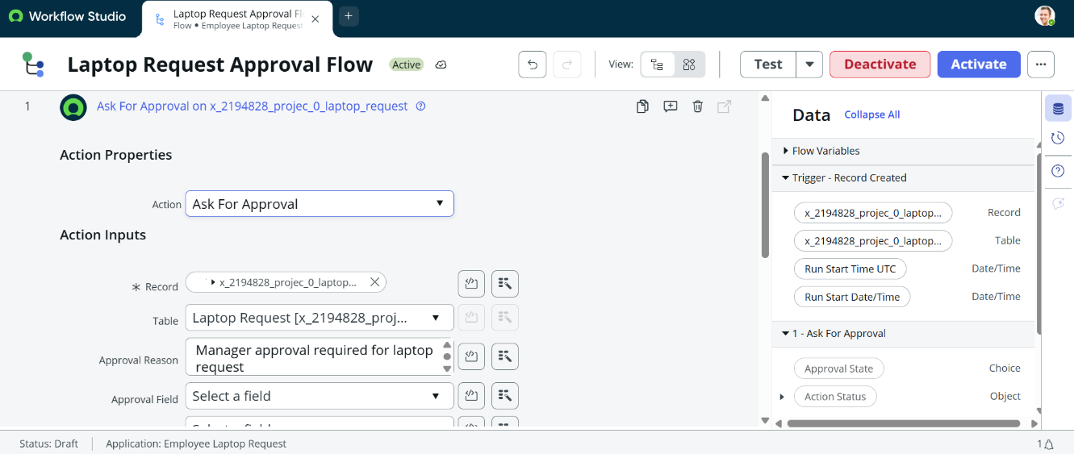
- Laptop Request – Ask for Approval Flow Action

- Laptop Request - Email Notification Action
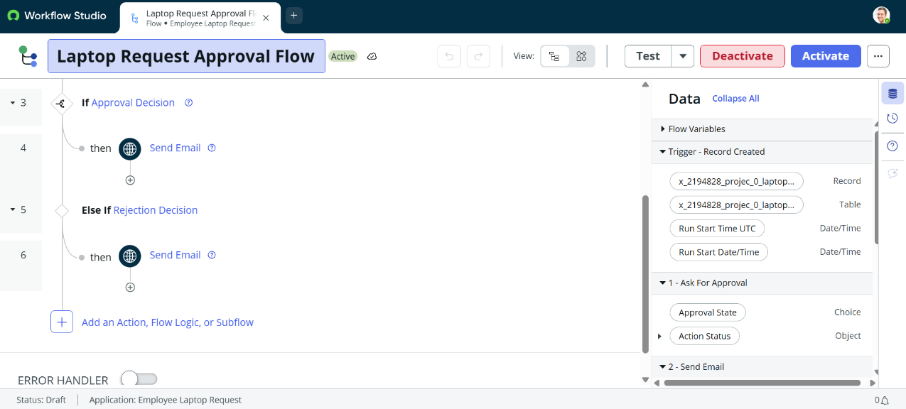

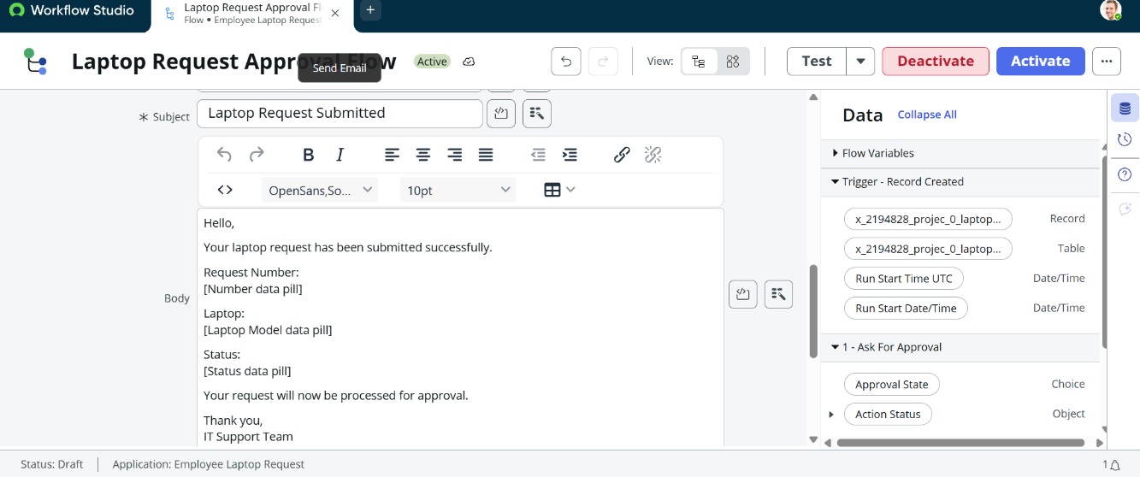
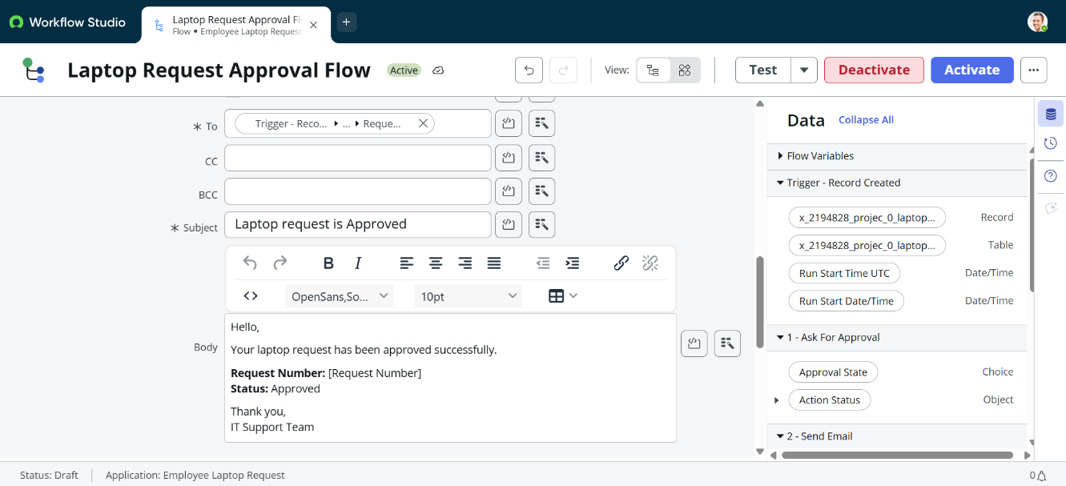 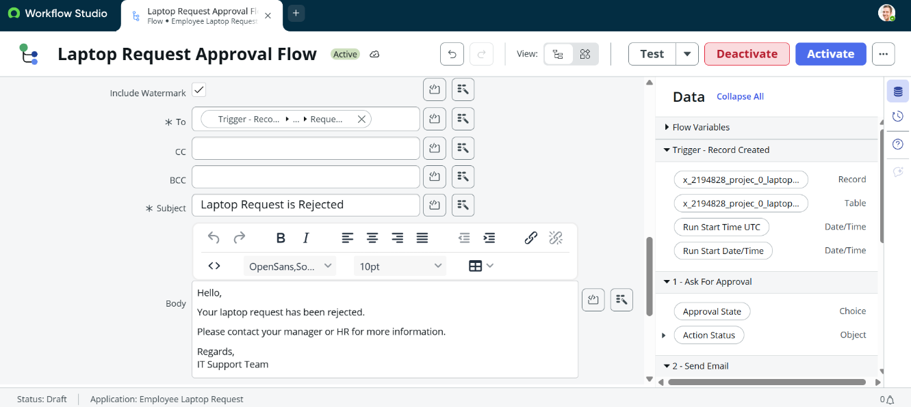8.Business Logic & Validation
- ALL >> Business Rule
Business Rule Name: Laptop Request BR
Purpose: Prevent an employee from submitting more than one laptop request during the same calendar year.
Execution: Before Insert
Validation Logic:
- Identify the requester.
- Check existing requests for the current year.
- If a request already exists, prevent insertion.
- Display an error message to the employee.
Expected Error:
You have already submitted a laptop request for this year.
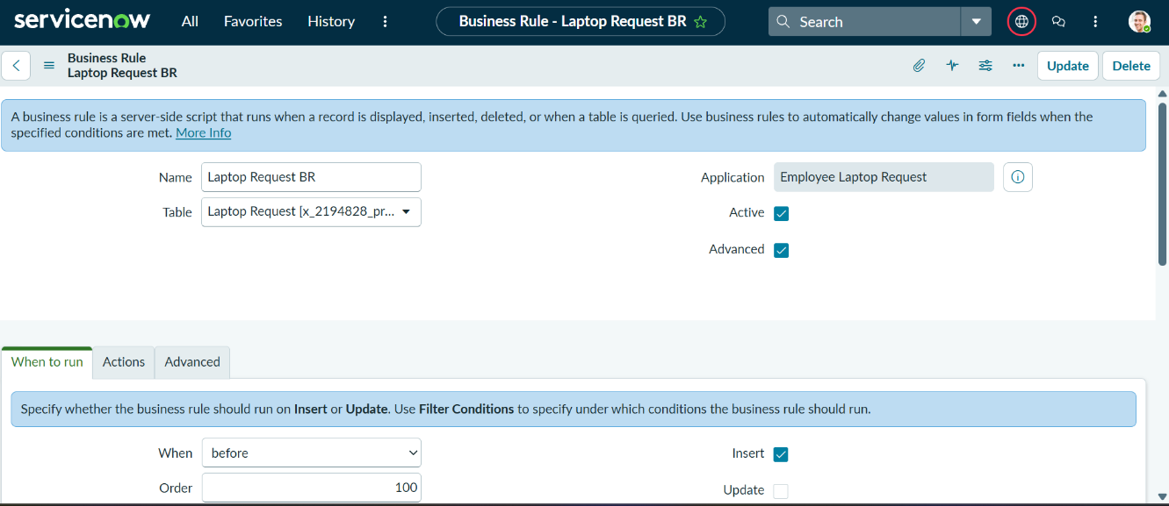
- Configuration of Business rule

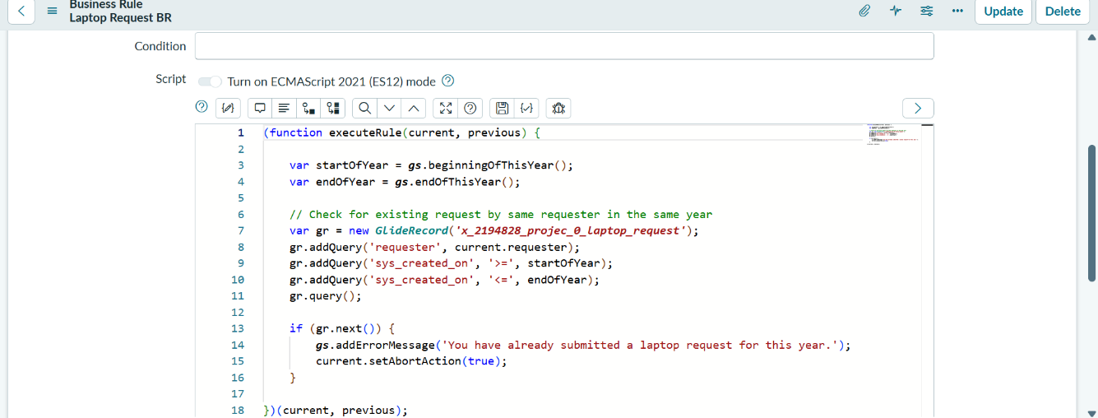
- Error message
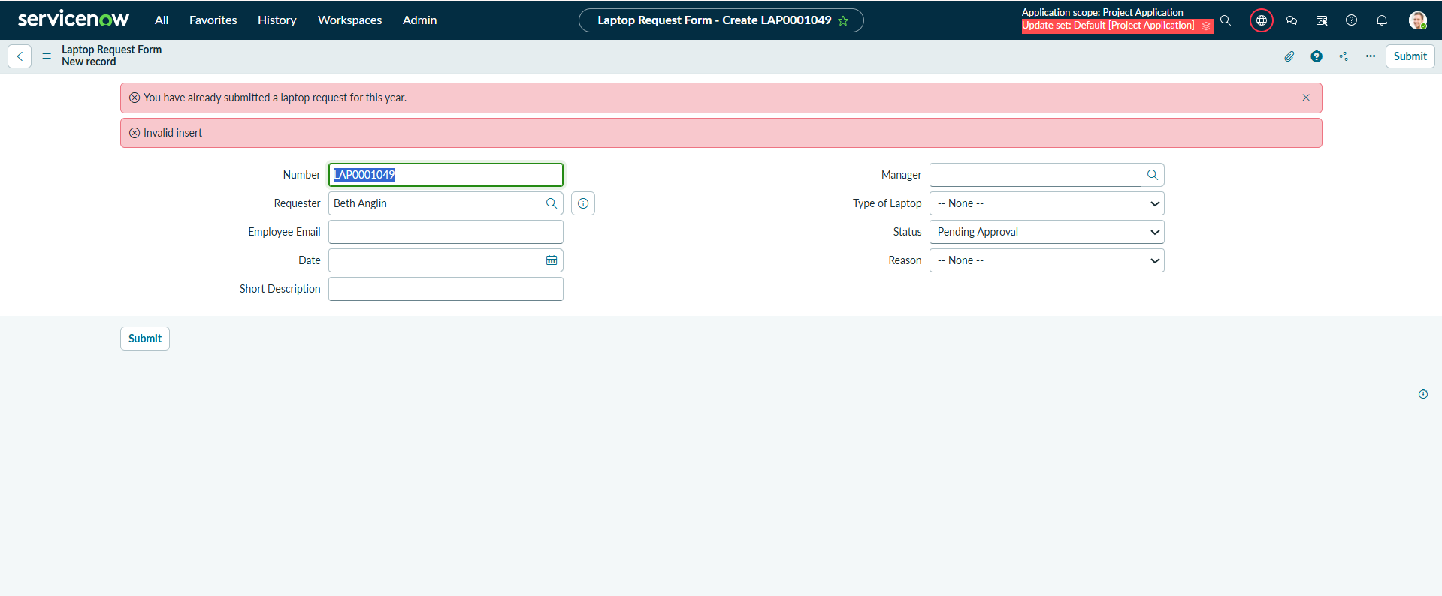

8. Security & Access Control.
- To control access to the application using role-based security.
- On all menus >>search for roles under users and groups and select it.
- Now select new button to create two new roles.

Roles
- it_employee

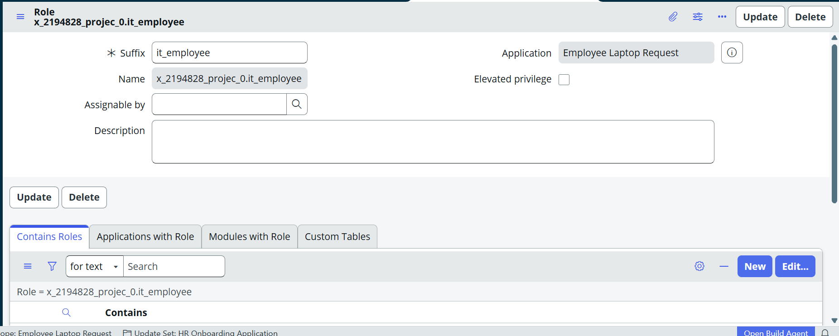
- it_manager

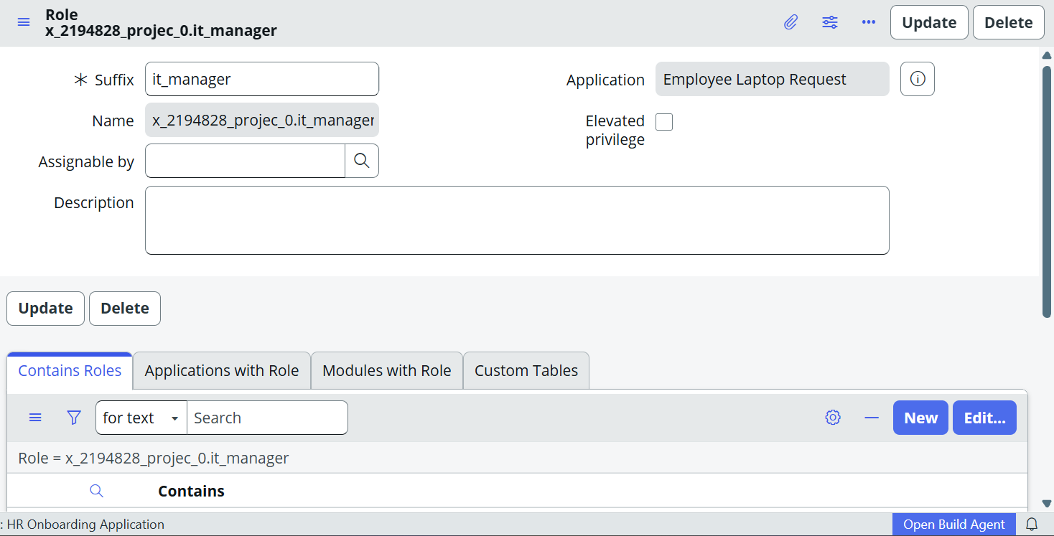

Groups
- IT Employees
- IT Managers

Access Controls(ACL’s):
IT Employee:
- Create
- Read
- Write
IT Manager:
- Read

- IT Managers group
- Manager Read ACL
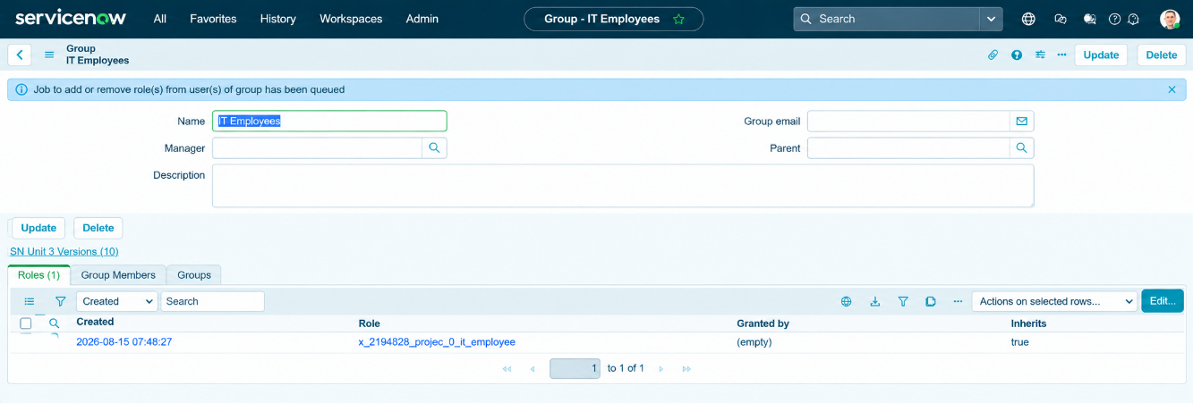
- IT Employees Group
- Employee Create/Read/Write ACLs

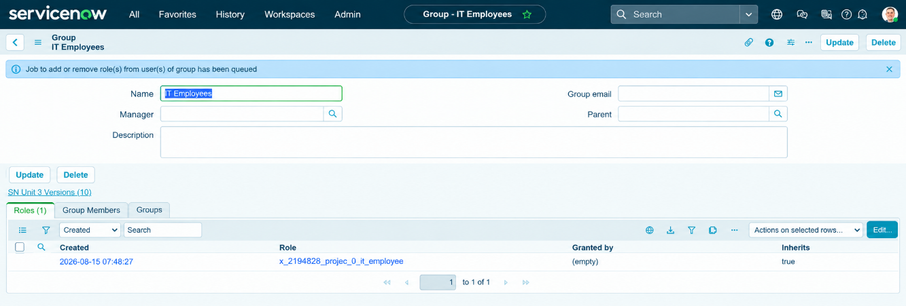

9.Testing & Validation

The main objectives of testing are:
- To verify that employees can create laptop requests.
- To verify that all required fields accept valid data.
- To verify that laptop request records are created successfully.
- To verify that requests are sent for manager approval.
- To verify that managers can approve or reject requests.
- To verify that request status is updated correctly.
- To verify that email notifications are triggered.
- To ensure that the application works without unexpected errors.

- Creation of Laptop Request and sent for Manager Approval
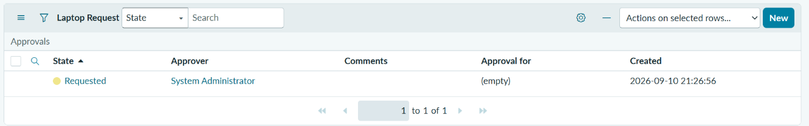
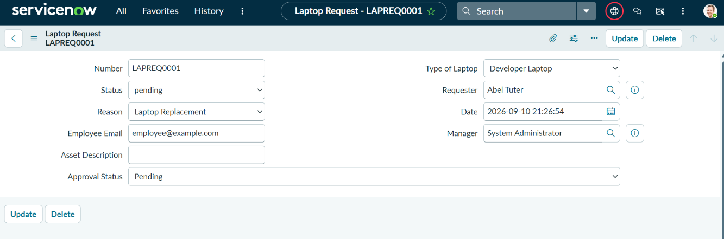
Work Flow Testing
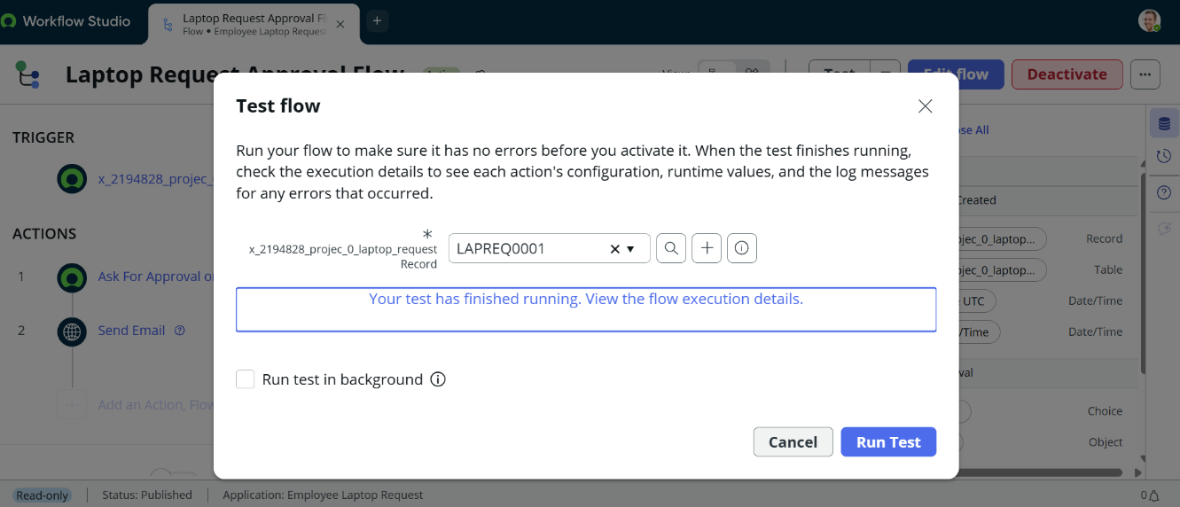

- Notification Testing
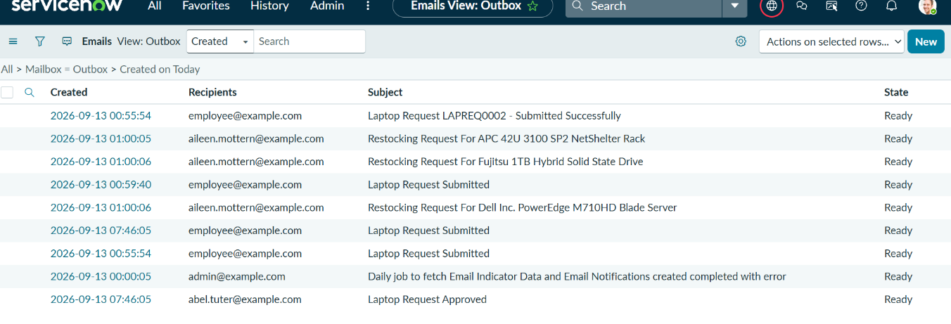

- Manger Approval
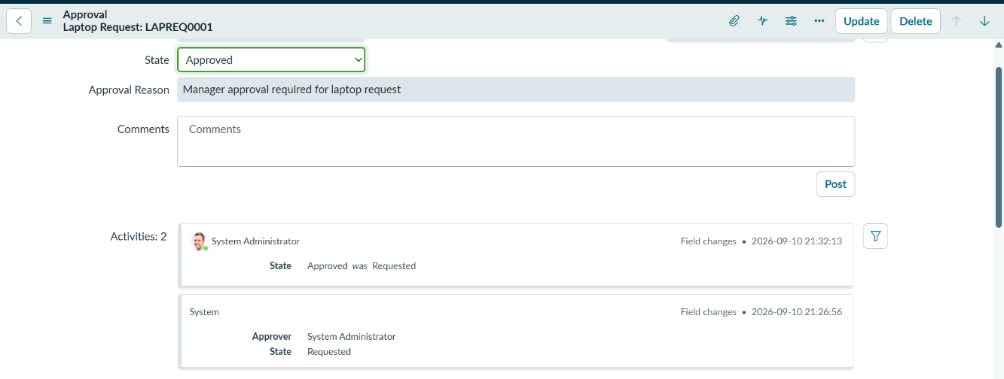

- Testing Result
The ServiceNow-Based Employee Laptop Request Application was tested for its major functionalities. The testing covered request creation, employee details, laptop selection, manager approval, rejection, notifications, status updates, Flow Designer execution, and access control.
The test cases confirmed that the major components of the application work as expected.

- Conclusion
The ServiceNow-Based Employee Laptop Request Application provides an efficient and automated way to manage employee laptop requests within an organization.
Overall, the project reduces manual work, improves request tracking, provides a structured approval process, and increases efficiency in managing employee laptop requirements. The system demonstrates how ServiceNow can be used to automate and manage an organization's internal employee service requests.

Thank You

